**The Silver Family History**

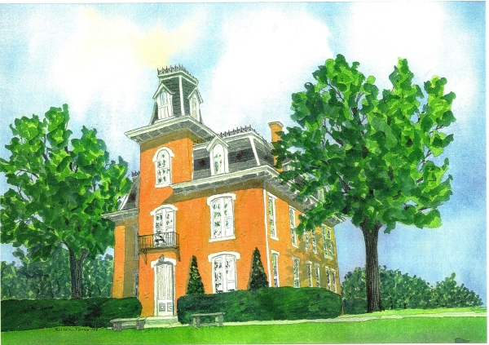

***by***

***Amy Ellen Silver***

**Introduction**

We trace our family back to Archibald Silver. His birth date and names of his parents are unknown, but he is assumed to have been born in Scotland. He is identified in David Dobson's book, *The Original Scots Colonist of Early America, Supplement 1607-1707,* page 156, as an earlier settler. Dobson's entry for Archibald Silver, Senior, is as follows:

"SILVER ARCHIBALD, married Christian Cheyne in Matocopine, West New Jersey, 16 [EJ Deeds, Liber A, fo. 226; Liber D]" (Nelson, 1899)

In David Dobson's book, *The Scottish Surnames of Colonial America,* he provides a description of the origin of the surname "Silver", which is quoted as follows:

"SELLAR, SILLAR, SILVER. An occupational surname, possibly from the middle-English word 'seler' meaning 'saddler', or from the French word 'celier' meaning cellar-man. A surname used in Scotland since the thirteenth century. Archibald Silver was in East New Jersey by 1685, and Hugh Sillar, from Argyll, emigrated to North Carolina in 1774." (Dobson, The Scottish Surnames of Colonial America., 2003)

Archibald Silver settled in West New Jersey. At this point, we can obtain a wealth of information about his family, religion, trade and property from various historical documents. A substantial amount of information was obtained by reading several books written by David Dobson. David Dobson is an honorary research fellow with the Research Institute of Irish and Scottish Studies, King's College, University of Aberdeen. He is the author of nearly fifty genealogical or historical sourcebooks. [As a personal side-note, our son (the author and Peter Silver Generation 9), Scott Silver, Generation 10, spent a semester abroad studying at the University of Aberdeen. He choose Aberdeen out of the blue. It is interesting to note that he was returning to his roots.] This information and more will be shared below.

**Settled in West New Jersey:**

Archibald Silver settled in, what was called at that time, West New Jersey. According to a web-site search (westjersey.org/wj_line.htm), " The East Jersey/West Jersey line was defined in a 1676 Quintipartite Deed between Sir George Carteret and Edward Billinge, (and the three Billinge Trustees: William Penn, Gawen Lawrie and Nicholas Lucas)." The line was settled to extend from Little Egg Harbour to a point on the Delaware in 41 degrees of north latitude. This was the way the present day State of New Jersey was divided.

Archibald Silver's family settled in what was then called, Matocopine, West New Jersey. Based on the results of two message board postings on Ancestry.com, it is believed that Matocopine, West New Jersey, is located in present day Burlington County along the north bank of Assunpink Creek, in Bordentown, New Jersey.

According to a Wikipedia search, the Assunpink Creek is a 22.9-mile-long (36.9 km) tributary of the Delaware River in western New Jersey. The Wikipedia post further states, the Assunpink Creek comes from the Lenape word, meaning "stony, watery place."

You may wonder why he chose to settle in West New Jersey. One clue for his decision to settle in this area is that he was a Quaker. He joined other Friends who wished to form a Quaker colony in the new world.

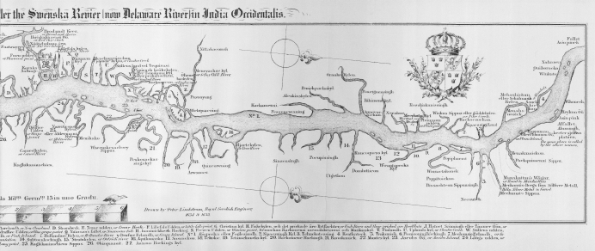

**1655 Delaware river chart – 'Asin Pink' is marked on far right**

[Source: <http://en.wikipedia.org/wiki/Second_Battle_of_Trenton> ]

Information about the founding of West New Jersey can be found In John E. Pomfret's article *The Proprietors of the Province of West New Jersey, 1674 - 1702, printed* in *The Pennsylvania Magazine of History and Biography,* Vol. 75, No. 2 (Apr., 1951), pp. 117-146. Published by: The Historical Society of Pennsylvania. [Article Stable URL: http://www.jstor.org/stable/20088236] In this article, John E. Pomfret, stated that the establishment of West New Jersey was a concerted effort of the Friends to create a self-contained Quaker Colony in America. He noted that of the one hundred and twenty proprietors of West Jersey and the twelve proprietors of East Jersey, all but one were members of the Society of Friends. Additionally, he mentioned that Charles II by royal patent conveyed what was to become of New Jersey to his brother James (the Duke of York) in 1664. The Duke of York presented the patent to two loyal supporters. One of the supporters, John Lord Berkeley, in 1674 sold his interests to two Friends, Edward Byllynge, a brewer of Westminister, Middlesex, and John Fenwick for ***one thousand pounds***. The colonizing of West Jersey took place during the proprietary period, 1674-1702.

In 1675, due to financial troubles, Byllynge had to form a trusteeship of his interest in West Jersey. It was called the Byllnge Trustees and comprised of three Friends, William Penn, Gawen Lawrie, and Nicholas Lucas. The Trustees wanted to sponsor a Quaker colony. In 1680, the Trustees obtained from the Duke of York and the Crown a formal acknowledgment of a right to govern the province. The Trustees signed agreements with prospective settlers in the Burlington, New Jersey area.

On October 8, 1686, Archibald Silver, a planter, purchased a deed for 100 acres of land, being a 1-52 share for the first taking up, from Edward Bylling (Byllynge), Governour of the Province of West Jersey. This information can be found on page 514, from the West Jersey Records, Liber B, part 2, p. 645.

**What do Quakers believe?**

The following information about Quakers was obtained from an article in Microsoft Encarta Reference Library 2003. The Society of Friends or Quakers are a designation of Christians who believe that divine revelation is immediate and individual; all persons may perceive the word of God in their souls ("inward light" or "Christ within"). They had a separate paid Clergy, but they had no formal creed, worshiped in silence, and regarded everyone as a potential vessel for the word of God. Quakerism was a way of life: they tried to live in accord with Christian principles; they avoided luxury and dressed simply; and they were egalitarian.

The Quakers were persecuted, because they refused to take oaths; were against war and self-defense; and they opposed the authority of church or state. They would not pay tithes to the Church of England and they worshiped publicly and not in the Church of England. Many Quakers were jailed and fined, because of this.

**What was happening in Scotland during the period that Archibald Silver and other Friends decided to strike out for the New World?**

Information about the rise of Quakerism in Scotland can be found In G.B. Burnet and William H. Marwick's Book, *The Story of Quakerism in Scotland 1650-1850,* ISBN# 9780718891763, June 2007, published by The Lutterworth Press, pp. 11-12 and 29-33. In this book, the authors stated that the Society of Friends Movement orginated in 1647, the year the famous Quaker George Fox began to preach in England. At that time, the Movement called their Society the "Children of Light" or the "Friends of Truth".

George Fox was arrested for attempting to harangue the congregation in a Church at the close of a lecture. He was arrested and required to appear before the magistrates at Derby in 1650. In his defense, he imitated the Prophets in calling upon the Justices to "quake at the Word of the Lord". One of the justices wanted to scorn Fox and his followers by calling them "Quakers". According to the authors, the Society of Friends have never regarded any visible trembling or commotion as a necessary expression of the indwelling power of the spirit. However, they appeared not to dislike being called "Quakers".

Quaker followers began to be persecuted in Scotland in 1656. They were persecuted by ministers of the Church and by civil magistrates. The magistrates used Cromwell's Vagrancy Act of 1656, to prosecute Quakers. The Act was intended to control troublesome beggars but was extended to cover Quakers who preached their doctrine in public on the streets. Some Quakers were: pelted with mud and stones; attacked by mobs; placed in stocks; fined twenty shillings sterling; and committed to the Hamilton Tolbooth, if they could not pay or if they refused to pay the fine. Additionally, some Quakers were then removed to Glasgow and imprisoned for three weeks and excommunicated.

Burnet and Marwick, noted that the first Quaker marriage in Scotland, occurred in 1656. Quakers married as "contracting partners" in the presence of witnesses. The married couple found themselves in front of the magistrates in Hamilton and charged with cohabiting. The husband was fined twenty shillings, with the alternative of twenty stripes on his bare body at the Mercat Cross on market day and was prohibited from cohabiting with his wife. He was handed over to a recruitment officer for the French wars, and he was transferred from the Hamilton Tolbooth to the Canongate Tolbooth in Edinburgh until he should go overseas. He later was set free.

In May 1657, the Synod of Glasglow excommunicated the Quakers as a body. This meant that all of the Church's parishioners were forbidden to have any business dealings with Quakers or drinking, lodging or entertaining with the members of the Friends.

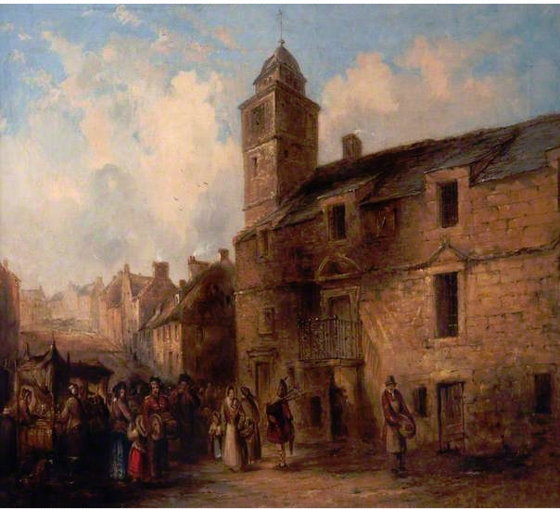

The Old Tolbooth Hamilton, by James Grimson

Date painted: c.1832

Oil on canvas, 46 x 63.8 cm

Collection: South Lanarkshire Council

**What Prompted Archibald Silver and other Members of the Society of Friends to Settle in New Jersey?** (Bowden, The History of the Society of Friends in America, 1850)

Before 1664, the territory of New Jersey was owned by the Dutch. The English took this territory by conquest. Initially, the area was settled by Puritans from New England and shortly thereafter, a few families from the Society of Friends colonized there.

According to James Bowden:

"The successful colonization of New Jersey, like that of New England, was a result of the Reformation, but not arising from efforts of the Church of Rome to regain her lost power in Christendom, so much as from the antichristian and unwise policy of Protestant England in enforcing conformity to the national church."

Bowden stated further that this led to Puritans and Papists from England, exiled Covenanters from Scotland, Huguenots from France, and the Society of Friends to seek refuge in the new world, due to religious persecution.

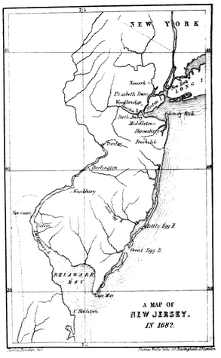

John Fenwick, one of the original trustees of the state of New Jersey, came with a number of other Friends, in the *Griffith*, from London, in 1675. This was the first English ship to touch the shores of West Jersey. They created a permanent settlement, which they named Salem.

In March,1676, the charter or fundamental laws of West New Jersey were settled and passed. The Society of Friends established that:

no one should have the authority to rule over men's consciences in religious matters; no man was to be imprisoned for debt; courts were to be conducted without attorneys; the aborigines were protected against encroachment; the state was responsible for educating helpless orphans; and all inhabitants of the province were to be free from oppression and slavery.

Advertisements were made in England to invite prospective individuals to emigrate to West New Jersey. William Penn, Gawen Lawrie and Nicholas Lucas, all Friends, wrote a cautionary letter advising other Quakers to deliberate thoughtfully on their decision to emigrate to the new world.

A portion of their letter is provided as follows:

"This am I, William Penn, moved of the Lord, to write unto you, lest any bring a temptation upon themselves or others; and in offending the Lord, slay their own peace. Blessed are they that can see and behold Him their Leader, their Orderer, their Conductor and Preserver, in staying or going: whose is the earth and the fullness thereof, and the cattle upon a thousand hills. And as we formerly wrote, we cannot but repeat our request unto you, that in whomsoever a desire is to be concerned in this intended plantation, such would weigh the thing before the Lord, and not heavily or rashly conclude on any such remove; and that they do not offer violence to the tender love of their near kindred and relations; but soberly and conscientiously endeavour to obtain their good wills, the unity of Friends where they live; that whether they go or stay, it may be of good savour before the Lord (and good people), from whom only can all heavenly and earthly blessings come.

This we thought good to write for the preventing of all misunderstandings, and to declare the real truth of the matter; and so we commend you all to the Lord, who is the watchman of his Israel. We are your friends and brethren, William Penn, Gawen Lawrie, and Nicholas Lucas"

An advertisement encouraging Scots to emigrate to New East Jersey, can be found in David Dobson's book, *The Original Scots Colonists of Early America, Supplement 1607-1707, in the appendices.* The advertisement was written in 1684, two years before Archibald Silver purchased his 100 acres of land in West New Jersey. The notice is written in old English, which is a little bit difficult to read, but is intelligible. It appears they used the letter "f", in lieu of the letter "s" for many words (for example: tradef-men, instead of trades-men or pleafure, instead of pleasure).

Notice was given to "all Tradef-men, Hufband men and others, who are willing defirous to go there, and are able to Tranfport themfelves and Families thither, upon their own Coft and Charges, to a pleafant and profitable Countrey, where they may live in great Plenty and Pleafure, upon far lefs Stock, and with much lefs labour and trouble then in Scotland, that as foon as they arrive there, they fhall have confiderable quantities of Land, fet out Heretably to themfelves and their Heirs forever, for which they fhall pay nothing for the firft four or five years, and afterwards pay only a fmall Rent yearly to the Owners and Proprietors thereof, according as they can agree."

If you were a Tradef-men, Servant, or others, fuch as, Wrights, Coupers, Smiths, Mafons, Millers, Shoe-makers, etc. and you were willing to go there, but could not pay for your transport, you could be carried over for free and well maintained in meat and clothes for the first four years of service and afterwards you would be given your own land. The type of service expected included: cutting down wood with axes, other kinds of husbandry work and being a servant. By going you would have more opportunities for riches and would prevent your family from begging, starving, and not having clothes to wear. They provided the following description of West New Jersey and stated it would be a much preferred life than begging on the streets in Scotland:

"....And yet can hardly be perfwaded to go to a moft profitable, fertile and fafe Countrey, where they may have everything that is either neceffary, profitable or pleafant for the life of Man, with very little pains and induftry; The woods and Plains are ftored with infinite quantities of Deer and Rae, Elcks, Beaver, Hares, Cunnies, wild Swine, and Horfes &c. and Wild-honey in great abundance: The Trees abound with feveral forts of Wine-grapes, Peaches, Apricoks, Chaftnuts, Walnuts, Plumbs, Mulberries &c. The Sea and Rivers with Fifhes, the Banks with Oyfters, Clams &c. Yea, the Soil is fo excellent and fertile, that the Meadows naturally produce plenty of Strawberries, Purpy, and many more tender Plants, which will hardly grow her in Gardens: Wheat, Ry, Barley, Oats, Peafe and Beans, &c. when fown yields ordinarly 20, and fometimes 30. fold Increafe, and Indian-Corn, which is a Grain both wholefome and pleafant, yields ordinarly 150. and fometimes 200. fold; Sheep never mifs to have two lambs at a time, and for the moft part three, and thefe Lambs have generally as many the next year; The Winter lafts not ordinarly above two moneths; and one Mans ordinary Labour will with eafe and plenty, maintain a Family of ten or twelve Perfons; It was no wonder then that Ogilvie in his New-Atlas, calls this place the Garden of the World, and the Terreftrial Paradife....."

How appropriate, the present day State of New Jersey is nicknamed "The Garden State." You would have been crazy to not want to move there. If you had any lingering doubts, the advertisement had other persuasive arguments.

If you were concerned about the long and dangerous journey by ship, they countered that it takes a mere six to seven weeks to sail from Scotland. If you have good company on your ship and travel during the summertime, it is a rather pleasant endeavor with no trouble or toil. They remarked it is certainly more dangerous to sail from Leith (note: port north of the City of Edinburgh, Scotland) to London or Holland, then to New-East-Jersey.

If you worried about lack of civilized company and barbarians living in the woods of New-East- Jersey, they remarked there are already plenty of English and Scottish people there and more coming every day. They stated the mountains here in Scotland are far more wild and inhospitable then the woods there. The natives are very few and are easily overcome. They are simple and serviceable creatures and are rather a help and encouragement, then in any way hurtful or troublesome.

They also provided a list of prominent Gentlemen going from Scotland that Summer to the new world. They were referenced as being persons of good quality and estates, who choose to go not out of necessity, but by choice.

Archibald Silver married Christian Cheyne, who came over as an indentured servant and who was imported by George Keith, in 1684. Maybe Christian read a similar advertisement and took a chance on a better life. She arrived two years before Archibald Silver purchased his 100 acres of land. In February,1685, Archibald married Christian in Matacopine, West New Jersey. For what reason, Archibald choose to come to West New Jersey, we may never ascertain with certainty.

The Scottish and English Quakers came over in waves. As mentioned earlier, the first English ship landed on the Jersey shores in 1675. In 1677, two hundred and thirty proprietors of West New Jersey sailed from London in two companies, one from London and one from Yorkshire. According to James Bowden, the circumstances of so large a number of Friends emigrating in a body to America, attracted public attention. He stated further that, the King participated in this feeling, and, meeting the ship, whilst yachting on the Thames, and being informed that the passengers were Quakers who were bound for the new country, "he gave them his blessing." Bowden estimated that the number of Friends who emigrated to the new colony during the years 1677 and 1678, is stated to be about eight hundred and a large number of them were people of property. Up to fourteen hundred people had emigrated to West New Jersey by the year 1681. Bowden referenced that the new settlers wrote encouraging letters to their Friends back in England and Scotland.

In February 1681, William Penn and other influential members of the Society of Friends decided to purchase East Jersey. Bowden referenced that this purchase coincided with the era of civil wars in England. During this period, the followers of Cameron in Scotland were hunted down with great cruelty by the Royalists. The East and West New Jersey Quaker colonies became very popular to the persecuted Scots. At this time considerable numbers left their mountainous regions in Scotland to start a new life in the forests of the Jerseys. The original twelve proprietors of the Jersey provinces extended proprietary to twelve others, several whom were high ranking and influential natives of Scotland. Archibald Silver was settled in New Jersey sometime before 1685 and his wife to be, Christian Cheyne arrived in 1684. Maybe they left because of being persecuted for their beliefs, during this period of civil wars in England.

**How did the Quaker Emigrates Treat and Interact with the Native Americans?**

According to Bowden, the Friends treated the Native Americans with respect. When William Penn and his fellow Quakers settled in the area where present day Burlington, New Jersey, now stands, they made several purchases of land from the natives. Due to the fact, the Friends did not have goods sufficient to pay for the land they bought, they agreed to not occupy any part of the land until it was fully paid for.

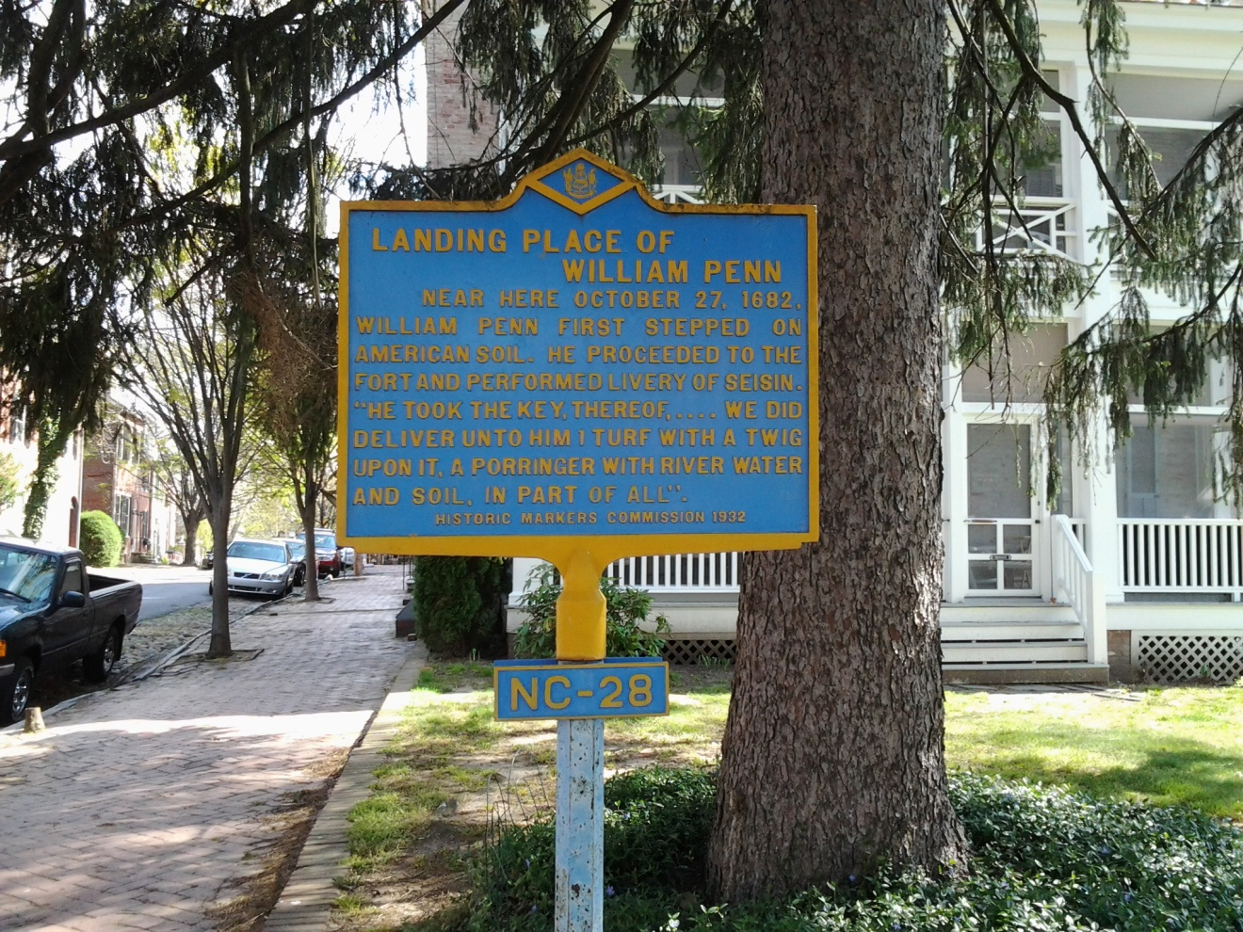

Picture taken in Historic New Castle, Delaware, along the Delaware River

He stated further, the earliest settlers in West New Jersey faced many hardships. During their first winter, they hastily built wigwams to live in. The aborigines were sympathetic to the hardships of the new settlers whom they supplied with corn and venison, and this could be attributed to the Christian conduct and goodwill of the Friends towards the Indians.

One of the first settlers who embarked from Hull on the ship named the Shield, in 1678, wrote the following:

"A providential hand was very visible and remarkable, in many instances that might be mentioned; and the Indians were even rendered our benefactors and protectors. Without any carnal weapon we entered the land and inhabited therein, as safe as if there had been thousands of garrisons; for the Most High preserved us from harm, both of man and beast."

As referenced in Ezra Michener's book on Quakers, during the 1685, Yearly Meeting, the following was affirmed:

" This meeting doth unanimously agree, and give as their judgment, that it is not consistent with the honor of Truth, for any that make profession thereof, to sell rum or other strong liquors to the Indians, because they use them not to moderation, but to excess and drunkenness."

During the 1719, Yearly Meeting, the Friends agreed: " To avoid giving them (the Indians) occasion of discontent, it is advised that Friends do not buy or sell Indian slaves."

**Where did the Quakers Worship in Their New Home**?

In West New Jersey, the Silver family relatives worshiped at Burlington, Chesterfield, Haddonfield, Piles Grove, Lower Alloways Creek and Salem Meetings. Their involvement with these various meetings will be discussed at length later in this document. The areas listed above can be seen on this map of New Jersey provided below.

Below: The map (dating from ca. 1850) shows many of the towns that had Friends meetings in New Jersey. It is a detail from James Bowden, *The History of the Society of Friends in America* (Vol. II: *Pennsylvania and New Jersey* (London: W & F.G. Cash, 1854).

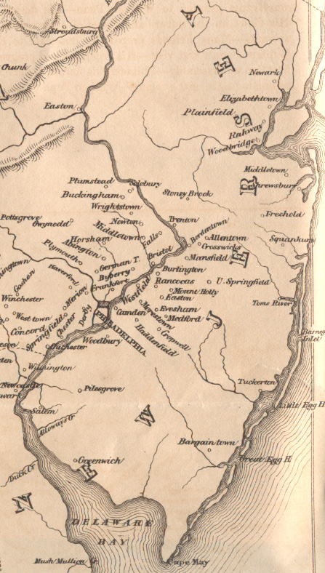

The early settler quoted in the section above also described their early worship in West New Jersey:

"The aforesaid people were zealous in performing their religious service; for, having at first no meeting-house to keep public meetings in, they made a tent or covert of sail-cloth to meet under; and after they got some little houses to dwell in, then they kept their meetings in one of them, till they could build a meeting house."

According to Ezra Michner, in his book, *A Retrospect of Early Quakerism,* the initial meetings for worship were held in peoples' houses. Next, they established *Monthly Meetings* for the right ordering of marriages and the receiving and granting of certificates. Eventually*, the Quarterly Meetings* were held every three months. When the Friends become more numerous in numbers and more widely dispersed, they were required to establish the *Yearly Meetings*. The yearly meetings were needed to embody the principles and practices of the Society of Friends; to establish a uniform order within the society; and to maintain discipline and the rightful authority within the church.

Within William Wade Hinshaw's, *Encyclopedia of American Quaker Genealogy,* he identified the names of four of the oldest monthly meetings which belonged to the Philadelphia Yearly Meeting of Friends. They are listed as follows: Salem Monthly Meeting, New Jersey (established in 1676); Burlington Monthly Meeting, New Jersey (established in 1678); Philadelphia Monthly Meeting, Pennsylvania (established 1682); and Falls Monthly Meeting, Pennsylvania (established 1683). He stated further that, the Philadelphia Yearly Meeting was sometimes called the Yearly Meeting of Pennsylvania, New Jersey, Delaware, and parts of Maryland and Virginia.

Within the Salem Monthly Meeting, Salem County, New Jersey, were established neighborhood meetings for worship. Early Silver's attended meetings held in Alloway's Creek, (Hancock's Bridge) and Pilesgrove (Woodstown). In 1784, Greenwich and Alloway's Creek were united as the Greenwich Monthly Meetings. In 1794, Pilesgrove Monthly Meeting was established. All of these monthly meetings were associated together within the Salem Quarterly Meeting, which was organized in 1682.

Silvers are also referenced in the Haddonfield Meeting minutes which was established as a monthly and quarterly meeting.

Hinshaw summarized further that, the Quakers kept minutes of their meetings which included the following types of records: births and deaths; marriage certificates; minutes covering all procedures and discussions coming before the monthly sessions of the meetings. Men and women met separately, in the Quaker tradition, and each kept their own minutes. Some meetings kept separate records for certificates of removal or received. They also kept disciplinary actions taken against members for violation of the rules of the Society. The type of activities that could get you in trouble with the Society of Friends included: fiddling and dancing, drinking intoxicating liquor to excess, serving in the militia or other armed forces, using profane language, fighting, failure to meet financial obligations, marrying contrary to the order used by Friends, deviation from plainness in apparel or speech, joining another religious society, etc. You would be disowned, unless you express sorrow and brought a signed paper condemning your actions. We will learn that some of the Silvers were subject to disciplinary actions, disowned and later reinstated in later sections of this document.

According to Hinshaw, thousands of Quakers were disowned. However, some would be reinstated after they produced the signed paperwork. This reinstatement could occur many years later. Others never asked to be reinstated and remained outside of the Society of Friends. Marrying contrary to the order used by the Friends, was the most common reason for complaints or disownment than any other offense, as referenced by Hinshaw.

Hinshaw elaborated further about the meaning of a *certificate of removal*. In order to move from one meeting to another, you had to receive a certificate of removal. This would be granted to members in good standing and served as a recommendation to their next fellowship. The member would have to have settled all financial obligations satisfactorily, in order to receive their certificate.

If a proposed married couple belonged to a different meeting, they were obligated to follow specific protocols, including requiring the man and woman to declare their intentions to get married in the woman's meeting house. The man had to provide a certificate from his meeting house that showed he was a member in good standing and free from marriage engagements with others. The man was not transferred to his future wife's meeting but allowed them to be married there. Typically, the wife would obtain a certificate of removal in her married name allowing her to join her husband's meeting.

Below: Map of the Philadelphia Meetings' Member Monthly Meetings

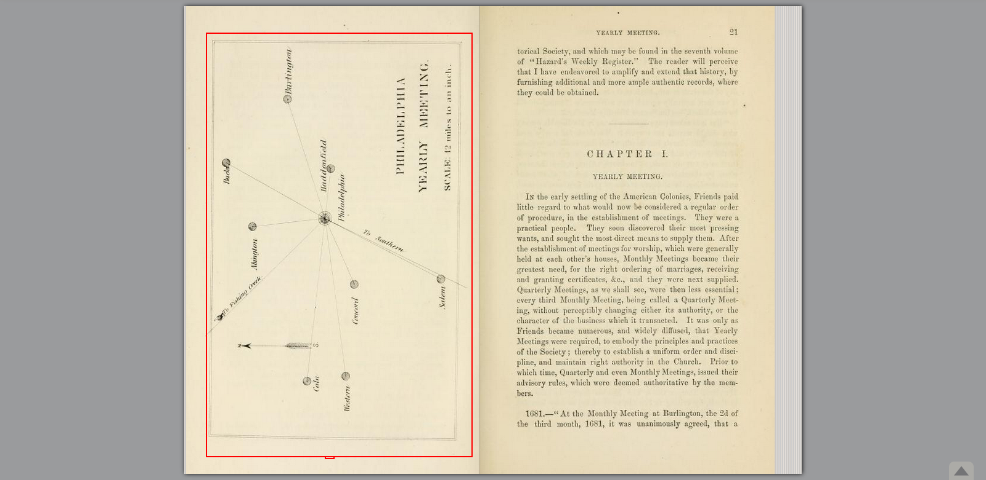

**Burlington Meeting House, Burlington, New Jersey**

In Burlington, meetings of worship were started in 1677 in tents, and afterwards held in peoples' houses. The first official monthly meeting was agreed upon in May 15, 1678 and was held in the houses of John Woolston and Thomas Gardner.

The Burlington Quarterly Meeting was set up in 1682 and held at the house of William Biddle until 1711. At that time the quarterly meeting was held alternately at the meeting houses in Burlington and Chesterfield.

The first meeting house was built in 1696. An illustration of the octagonal shaped Burlington meeting house is provided below. According to the Burlington Monthly Meeting minutes, it was ordered in 1682 that a meeting house be built, "according to a draught of a six-square building, of forty feet square from out to out."

The first meeting house was demolished and a new structure was erected in 1787. This meeting house has been restored and can be found at 341 High Street, in the City of Burlington, New Jersey.

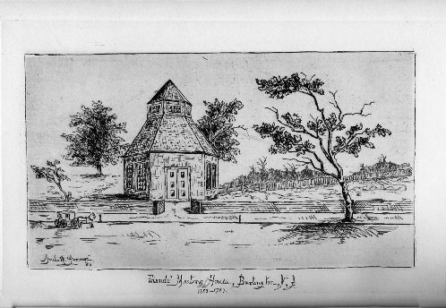

Above: Illustration of the Original Burlington Meeting House

Below: Present Day Burlington Meeting House

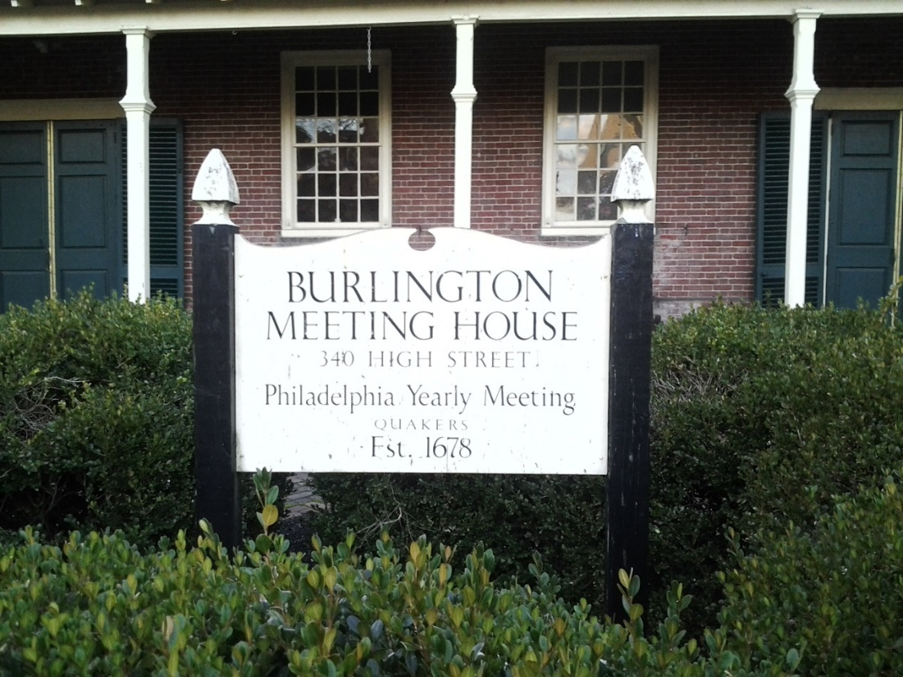

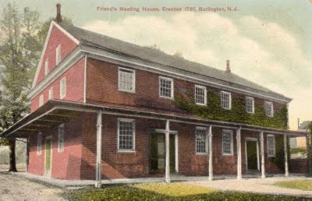

Above: Postcard of the Burlington Friend's Meeting House

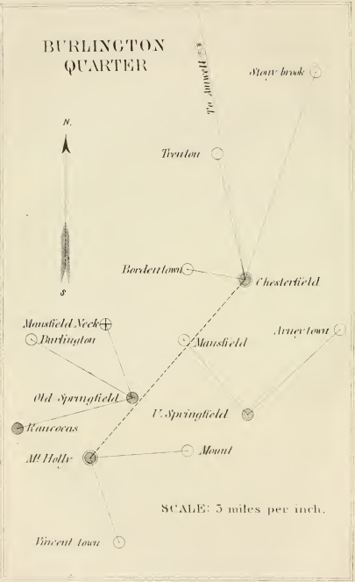

**Above: A Map of the Burlington Quarterly Meeting Members, from Ezra Michener's book.**

Within Ezra Michener's book referenced above, he gave an explanation for why the Quakers held separate meetings for the men and women. According to Ezra Michener, at a General Meeting held in Burlington, in June, 1681, at the house of Thomas Gardner, it was agreed that a Women's Meeting should be established. William Penn is quoted, in his Just Measures, as follows:

"But it is asked, why should women meet apart? We think for a very good reason. The church increaseth, which increaseth the business of the church, and women, whose bashfulness will not permit them to say or do much, as to church affairs, before the men, when by themselves, may exercise their gift of wisdom and understanding, in a discreet care of their own sex, at least, which makes up not the least part of the business of the Church; and this, while the men are upon their own proper business, also, so that, as men and women make up the Church, men and women make up the business of the Church."

Quakers appear to admire a women's gift of wisdom and understanding, yet at the same time believe women are not able to vocalize and share this information within a mixed group of women and men of the Church.

**Chesterfield (or Crosswicks) Meeting House, Chesterfield, New Jersey**

In Chesterfield, Friends for some time held meetings in Friends' homes. The Chesterfield Meeting was settled in 1680 and has also been called the "Crosswicks Meeting". In 1692, the first log meeting house was built. In 1706, a replacement meeting house was built from brick and was located on Ward Avenue. The present meeting house was completed in 1773 and could be found at Front and Church Streets, in Chesterfield, New Jersey.

During the Revolutionary War the meeting house was used briefly as a barracks by the Hessians. During a skirmish at the North Crosswicks bridge, a cannon ball fired by the rebel troops was imbedded in the meeting house wall.

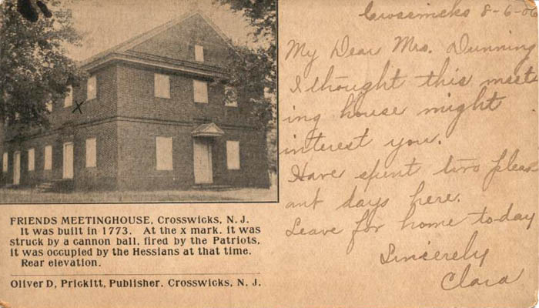

Above: Postcard of the Chester or Crosswicks Friend's Meetinghouse

**Haddonfield Friend's Meeting House, Haddonfield Friend's Meeting**

According to Ezra Michener, both the town and the meeting took their name from Elizabeth Haddon. The meeting house is built on land donated by her husband, John Estaugh, in 1721. As early as 1695 Friends were worshipping in the area, probably at the house of Thomas Shackles, and known at first as Gloucester Meeting. [Ezra Michener, *A Retrospect of Early Quakerism;*... (Philadelphia: T. Ellwood Zell, 1860; reprinted facsimile, Washington, DC: Cool Spring Publishing Company, 1991), 117-8, 119.] (Michener, 1860)

Below: Illustration of the Haddonfield Friends' Meeting, which was taken from James Bowden's *History of the Society of Friends in America*, vol. II, 1854.

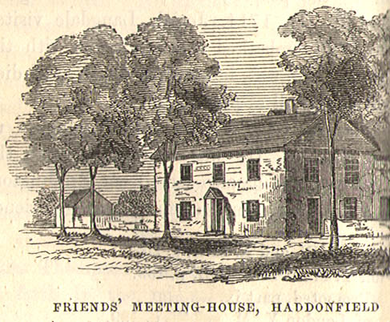

**Salem Meeting House, Salem, New Jersey**

According to Hinshaw, the Salem Friends' Meeting began with the arrival of Friends accompanying John Fenwick in 1675 on the *Griffin*. Fenwick and Edward Byllynge had purchased West Jersey from Lord Berkeley. As his share, Fenwick received the present Salem and Cumberland Counties. During 1675, the Friends first held their meetings for worship at each other's houses.

        Salem meeting minutes began on the last day of Fifth Month [July] 1676. Friends agreed to meet on:

"the first second day [Monday] of the weeke in every month, . . . to consider of outward business: and of such as have been convinced [i.e.those who were Quakers] and walke disorderly. That they may with all Gravitie, and uprightnesse to God and in tenderness of Spirit, and Love to their soules, be admonished, exhorted, and also reproved, and their Evill Deeds, and practice testified agst in the Wisdome of God and authoritie of Truth, wch may answere the Wittnes of God in them."   
[As quoted in William Wade Hinshaw, *Encyclopedia of American Quaker Genealogy* (1938) Vol. 2: Philadelphia, 17.]

        Hinshaw elaborated further, that in 1681, Samuel and Ann Nicholson sold 16 acres and a log building to the Meeting for £12. The meeting house, on East Broadway opposite Walnut Street, was enlarged and improved over the next few years. Then it was replaced with a brick building in 1700. The brick meetings house was built at a cost of £415. In 1772 the present meeting house was built, because they felt the old house was too small. In 1827 it remained in possession of the so-called Hicksites, while the Orthodox removed and in 1852 built themselves a smaller brick building at 107 West Broadway opposite the original burial ground. I think it is now a private house.

        The burial ground is on W. Broadway between 4th and 5th Streets. It was laid out in 1676, a year after the town was founded. Near the main entrance is the ancient Salem Oak, under whose branches John Fenwick bartered with the Native Americans, paying them for the land. [Lida Newberry, ed., *New Jersey: A Guide to its Present and Past*. rev. ed. American Guide Series (New York: Hastings House, Publishers, 1977), 330.]

Below: Postcard of Salem Friends' Meeting House, East Broadway, Salem, New Jersey [Source: [http://triptych.brynmawr.edu](http://triptych.brynmawr.edu/)]

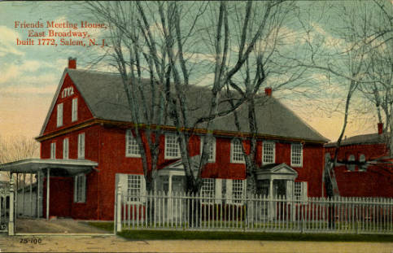

The Salem Quarterly meeting was established June 1, 1676.

Below: A Map of the Salem Quarterly Meeting Members, from Ezra Michener's **book.**

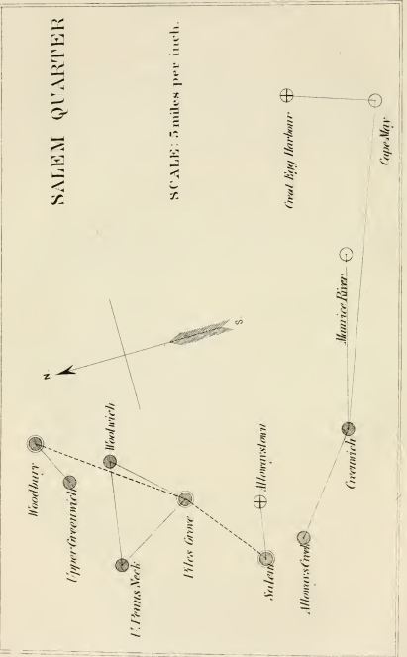

**Lower Alloways Creek Meeting House, Hancock's Bridge, New Jersey**

Below: Lower Alloways Creek Friends' Meeting House, Woodstown, New Jersey [Source: [http://triptych.brynmawr.edu](http://triptych.brynmawr.edu/)]

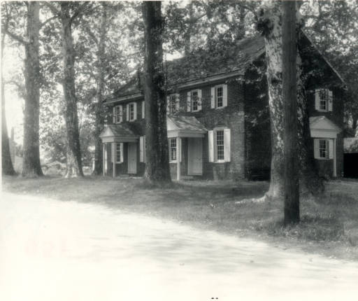

The Lower Alloways Creek Meeting is at Hancock's Bridge, but in the early days the meeting moved around a bit. In 1678 John Denn, Christopher White, Samuel Wade, Joseph Ware, Richard Hancock, Nathaniel Chambless, James Daniel, and Edward Bradway along with their families and other Friends settled around Alloway's Creek. They held meetings for worship and business at John Denn's house until 1684 when a meeting house was built on the north side of the Creek. It cost £40. But crossing the Creek was difficult so about 1710 another meeting house was built on the south side. Then in 1754 the present building was erected on land donated by William Hancock. The meeting house received an addition in 1784. [Ezra Michener, *A Retrospect of Early Quakerism;*... (Philadelphia: T. Ellwood Zell, 1860; reprinted facsimile, Washington, DC: Cool Spring Publishing Company, 1991), 45; Lida Newberry, ed., *New Jersey: A Guide to its Present and Past*. rev. ed. American Guide Series (New York: Hastings House, Publishers, 1977), 677. Newberry gives the date of 1756 for construction of the current meeting house.]

 Below: The photograph shows the stairway that goes up to the balcony or gallery of the meeting house

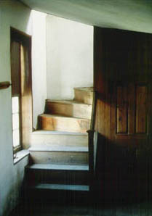

The meeting house is to the right of the Hancock House (now a museum). William Hancock (son of Richard) built the house in 1734. He and his wife Sarah's initials are in the gable end. During the Revolution, on 21 March 1778, the builder's son William, a judge who was crippled in both arms, along with three other elderly Friends, were asleep in their beds. About 20 militiamen were assigned to guard the bridge, and had their headquarters in the house. That night some "Jersey volunteers" (i.e. American Tories) led the British by back ways to the house. Upon entering they bayonetted everyone, including the four old Quakers sleeping upstairs. All 20 militiamen and four elderly Quakers were killed. [Robert H. Wilson, *Philadelphia Quakers, 1681-1981* (Phila. Yearly Meeting, 1981), 61. A somewhat different version of the story is given by Lida Newberry, ed., *New Jersey: A Guide to its Present and Past*. rev. ed. American Guide Series (New York: Hastings House, Publishers, 1977), 329, 676. There, it is William, not his son, and he sympathized with the Tory position. William fled during the rebel occupation of the area. When returning home on the evening of 20 March 1778 the revolutionaries seized him, and as many as 90 quartered themselves in his house that night. At that point Major Simcoe and 200 troops crept up to the house, crashed in both doors and systematically killed everyone who was unable to escape. Hancock and his brother were among those killed.]

    The soil of the area turned "sour" by the end of the 18th century, and people started leaving. Discovery of marl as a fertilizer, which was very common in that part of South Jersey, stopped the exodus. [Lida Newberry, ed., *New Jersey: A Guide to its Present and Past*. rev. ed. American Guide Series (New York: Hastings House, Publishers, 1977), 329.]

**Pilesgrove Meeting House (aka Woodstown), Woodstown, New Jersey**

According to Bryn Mawr College, Pilesgrove Monthly Meeting was established in 1794 by the Salem Quarterly Meeting. The Meeting House is located in Pilegrove Township, on North Main Street (Route 45), in Woodstown, New Jersey.

According to Ruth E. Bonner, the meeting was organized in 1720, and established as a monthly meeting in 1794. The present brick meeting house, constructed in 1785, is the second meeting house on this site. [Ruth E. Bonner, *Quaker Ways* (author, 1978), 34.]

Below: Pilesgrove Friends' Meeting House, Woodstown, New Jersey [Source:[http://triptych.brynmawr.edu](http://triptych.brynmawr.edu/)]

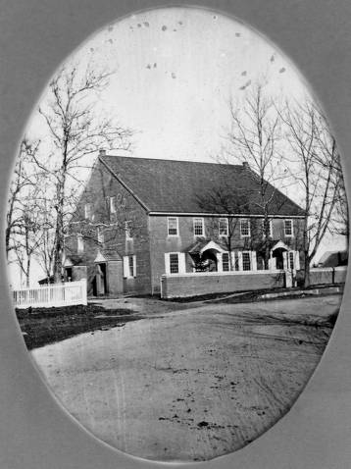

**What did the Quakers Expect from their Children and Youth?**

During the yearly meetings, the Quakers laid out their beliefs about the proper decorum of children and youth. Samples of these tenants are provided below:

1694. -" It is also a very evil thing, and hateful to God and all solemn people, for children to answer their parents again forwardly and crossly. Although they think they are out of the way, they ought to answer soberly and modestly, or not at all; for parents ought to be obeyed next to God. Nor ought you to act for yourselves against them : they have taken pains and care for you when you were young and helpless, and so ought you to do for them when they are old, if there be need."

1721.—"Advised that no Friend suffer romances, play-books, and other vain and idle pamphlets, in their houses or families, which tend to corrupt the mind of youth ; but, instead thereof, that they excite them to the reading of the Holy Scriptures, and other good and religious books."—(Yearly Meeting.)

1760.—" One prevailing danger which attends them (the youth) is the frequenting of public companies, such as are too often met with in taverns, fairs, and all places of public diversion, wherein, although they may see no harm at first, there is a snare in which many promising youth have been caught. Having been overtaken, in unguarded moments, not only with the current vanities, but even the infections of the wicked; and, as error is progressive and sin hardens the heart, they have gone on from one thing to another, till lamentable consequences have ensued. And as most disorders are more easily prevented than remedied, we advise Friends, in their Monthly Meetings, to take this matter under their care, and add their assistance, where necessary to the endeavors of individuals, to discourage it as much as in them lies." —(Yearly Meeting.)

**Why did the Quakers Advise Plainness?**

The expected manner of dress was also spelled out during the yearly meeting.

1694.—"We tenderly advise all, both old and young, to keep out of the world's corrupt language, manners, and vain, needless things, and fashions in apparel, and immoderate and indecent smoking of tobacco, " It is very unseemly, and not at all like Truth, to ride, or go in the streets with pipes in their mouths; for we ought, in all things, to take up the daily cross, minding the grace of God,

that brings salvation, and teaches to deny all ungodliness and

worldly lusts, and to live soberly and godly in this present

world, that we may adorn the Gospel of our Lord Jesus Christ. So shall we feel His blessing, and may be instrumental in His hands for the good of others." —(Yearly Meeting.)

1719.—"Advised that such be dealt with as do not keep

themselves and their children to moderation and plainness in gesture, speech, apparel, or furniture of houses;" .... "for, as those vain habits and needless fashions, by the levity too much prevalent among mankind, frequently change, so the vain and wanton mind in our youth and others is too apt to be taken

with, and fall into them." "Also such as accustom themselves, or suffer willingly their children, to use the corrupt, and unscriptural language of you to a single person ; or to call the week-days or months by names given them by the heathen, in honor of their gods ; it being contrai'y to Scripture and our

ancient testimony."—(Yearly Meeting.)

**How did the Quakers Promote Charity, Love, and Unity?**

The Quakers promoted charity, love and unity towards one another and to all mankind.

1706.—" We recommend unto you fervent and inward charity one towards another, and to all men ; for beside those commendations given unto charity by the Apostle, in his day, we also say by experience, that charity preventeth many evils. It keeps the peace, preserves unity, and, as it were, teaches

all duty. Where charity is, there is love to God and love to man; but where that is wanting, zeal toward God fails, and neighbors and friends are also disregarded, and, instead of acts and expressions of love and good-will to all, the contrary

is brought forth by such, which ought not. It is for want of

charity that men speak evil of dignities, detract and lessen the name of their neighbors, and evily intreat in secret the reputation of those that think them no harm. And this is a crying evil, from which the God of Truth purges and preserves

his people everywhere."—(Yearly Meeting.)

**How Were Quakers Disciplined?**

As described below, the Quakers were a very strict group.

1719._" Where any, professing Truth, are guilty of any

gross or notorious crimes, or such other disorders and indecent

practices as shall give or occasion public scandal, such, after dealing with by the Overseers, or other Friends, as advised and directed, if they are brought to a sense thereof, either by such dealing or by compunction, or true sight in themselves (which is more commendable), ought to appear as soon as possible at the Monthly Meeting whereunto he or she belongs; and, to the end that the scandal may be removed, and our holy profession cleared, as much as in them lies, there to acknowledge the offence, and condemn the same in writing, under his or her hand, to the satisfaction of the said meeting. And let such acknowledgment and condemnation be published by the said meeting in such manner as that it may probably reach as far, and become as public, as the offence hath been. And when any offender refuseth so to acknowledge and condemn the fault, then the said meeting ought speedily to testify, upon

record, against him or her, and the fact, and publish such testimony, so far as shall appear requisite for the clearing of Truth. "But if the offence committed be only against the Church, and not of public scandal, in that case, acknowledgment and condemnation by the party under hand, and the same entered

in the Monthly Meeting book only, is sufficient, without further

publication. And, upon the offender's refusing so to do, the meeting ought, after deliberate dealing and due admonition, to testify against them, according to the nature of the offence, and enter the same on their own minutes, whereby such persons stand disowned, until they shall repent and give satisfaction."

**What was the role of Overseers in the Quaker Religion?**

According to Ezra Michener, it appears to have been the practice of Friends, from a very early period, to appoint some of their number to preserve good

order, but without the specific name of overseers. Preparative Meetings seem to have grown out of those appointments, and will be best noticed in that connection.

1681.—"At a General Meeting, held in Burlington the last day of the sixth month, 1681, it is ordered, that each Monthly meeting do appoint two persons to follow reports, in order to find out the reporters ; and to minister justice upon all such

reports, that may tend to defamation or slander of any Friend

or person ; and also such reports as may be spoken out of Friends Men's and Women's Meetings."—(Burlington Monthly Meeting.)

1695.—"Advised that such as come late to meetings, or, when they come there, fall asleep, or be restless, or not stay in the meeting, but go forth, or otherwise behave themselves un- becoming our holy profession ; that, as soon as meeting is over, they be admonished thereof by such as are appointed to take care of such things; and that two or more men and women, out of their respective meetings, be from time to time chosen for that service; and such as will not receive their admonition, on their report to the said Monthly Meeting, to be further dealt with, as Friends in the wisdom of God shall see meet to direct."—(Yearly Meeting.) (Friends' Library.)

**What was the Purpose of the Quaker Certificates?**

According to Ezra Michener, it is the reasonable duty of an order-loving, religious society, when any of its members remove to another meeting, to furnish them with a certificate of their membership and circumspect walking; and such has been the early and continued practice of Friends. One example of a certificate is provided below. In this case, families were leaving England to settle in Pennsylvania. However, certificates were required when a person moved to a new town in the same state or to a new state.

1682.—"From Settle Monthly Meeting, the 7th of the

fourth month, 1682. These are to certify all those whom it may concern, that it is manifested to us that a necessity is laid upon several Friends belonging to this Monthly Meeting to remove into Pennsylvania, and particularly our dear friend Cuthbert Hayhurst, his Avife, and family, who has been, and is, a laborer in the Truth, for whose welfare and prosperity we are unanimously concerned ; and also for our friend Thomas Wrightsworth, and also his wife ; Thomas Walmsly, Elizabeth his wife, and six children ; Thomas Croasdale, Agnes his Avife, and six children; Thomas Stackhouse and Margery his wife: Nicholas Wain, his wife, and three children; Ellen Cowgill and family; who, we believe, are faithful Friends in their measures, and single in their intentions; to remove into the aforesaid Pennsylvania, in America, there to inhabit, if the Lord permit. And we do certify unity with their said intentions, and do desire their prosperity in the Lord ; and hope what is done by them will lead to the advancement of the Truth, in which we are unanimously concerned with them." (Signed by eleven Friends.)

The Ellen Cowgill and family, mentioned above, are relatives of the Silvers. They will be discussed at length later in this book.

The Friends named in the above certificate came over in the

ship "Welcome," in company with William Penn.

(Walter Lee Sheppard, 1985) According to Walter Lee Sheppard, in his book titled, *Passengers and Ships Prior to 1684, Penn's Colony: Volume I*, the Settle Certificate was found in the Liverpool port books for 1682, and all others cited, are in the Public Records Office, London; this particular one is E. 190/1345/11. Settle Certificate in Comly, MHSP, II, 182n. He stated further that the seven names given on the certificate are: Cowgill (our relatives), Chroasdale, Hayhurst, Stackhouse, Walmesley, Wlan, and Wrightsworth.

**What was the Quakers' Attitude Towards War?**

The following was taken from Ezra Michener's book on Quakers:

"The upright and pacific policy pursued by William Penn and

his followers, in administering the Governments of New Jersey and Pennsylvania, for a long time preserved them from hostile

collisions with the Indian natives; indeed, if such a policy had

been generally adopted and continued, collisions would never have occurred. But a different, a war policy, was adopted in some of the neighboring colonies, which soon involved them in hostilities with the Indians, and the Quaker Colonies were called upon, both by their sisters and by the home government, to assist in their defense. This they could not do otherwise than by interposing their friendly influence with the Indians, which was freely done. About the middle of the last century, when the war between England and France was carried into their American Colonies, causing what has been called the Canadian and Indian War,

each belligerent endeavored to turn the tomahawk of the savage

against the other, and with so much success as to cause much

cruelty and suffering in the frontier settlements. Friends could not take part in the warlike measures of the day, but by continuing their friendly intercourse and influence with the Indians, they were enabled to do more to repress their hostile incursions than they could possibly have done by a resort to physical force. Yet in those times of unbridled

passion and lawless violence, they were deemed by some as the

secret allies of the Indians, enemies of their country, and threatened with a general massacre.

The governing power had passed into other hands before the

struggle for independence commenced. Opposed to violence of every kind, Friends could not resort to physical force, either to set up, pull down, or reorganize any government; for, says Jesus Christ, " My kingdom is not of this world, else would my servants fight." They saw and deeply deplored the home policy towards the colonies; but their dependence was on God, and not on man. They believed, that if they continued to abide in a patient dependence upon him, that he would, in due time, dispose the hearts of the rulers to do them justice. Their principles were uncompromising; their path straight and narrow; they could do no consistent act, either to oppose the one party or to assist the other. But men who were accustomed to depend upon physical force for the redress of grievances, could hardly

be expected to appreciate the motives, or to respect the conscientious scruples of the non-resisting followers of Christ, in the peaceable government of his kingdom. Hence, it is not strange that Friends were subjected to severe sufferings, for maintaining their peaceable

testimony."

**During the Revolutionary War, Were the Quakers Willing to Pledge Allegiance and Abjuration to the Cause?**

The following was taken from Ezra Michener's book on Quakers:

"The Revolutionary War gave occasion for the enactment of laws imposing a "test" oath or affirmation, abjuring the King, and declaring allegiance to the American cause, and enforced by penalties, and, in some cases, by disabilities.

1778.—"On consideration of what is necessary to be proposed to Friends on the subject of declaration of allegiance and abjuration, required by some late laws by the Legislatures who now preside in Pennsylvania and New Jersey, we are united in judgment, that, consistent with our religious principles, we cannot comply with the requisitions of those laws,

as we cannot be instrumental in setting up or pulling down

any government; but it becomes us to show forth a peaceable and meek behavior to all men, seeking their good, and to live a sober, useful, and religious life, without joining ourselves with any party in war, or with the spirit of strife and contention now prevailing. And we believe that if our conduct is thus uniform and steady, and our hope fixed on the Omnipotent Arm for relief, He will, in time, amply reward us with lasting peace; which hath been the experience of our Friends in time past, and, we hope, of some now under suffering." "And as, in some places, fines and taxes are and have been imposed on those who, from conscientious scruples, refuse or decline making such declarations, it is the united sense and judgment of this meeting, that no Friend should pay any such

fine or tax."—(Yearly Meeting.)"

Ezra Michener stated further that some of the Quakers were fined and imprisoned for not signing a declaration of allegiance. The Quakers were unwilling to pay the fines. According to Michener, the colonists soon repealed the law after:

"The want of success which attended their efforts to extort

fines by means of imprisonment, soon satisfied them that they

could not coerce the consciences of men whose chief dependence was upon God, and led to the speedy repeal of the law; a law which filled the prisons but left the coffers of government agents empty. The laws which authorized the officers to distrain property whenever it could be found, were more successful, inasmuch as they left the peaceable and conscientious citizens (i.e., the Quakers) without any alternative but to suffer, and were continued in force, to the very great distress of Friends. The repeal of the law, " so far as respected the persons," the imprisonment of Friends, appears to have been more a necessity than a virtue. Little could be gained by imprisoning men, when neither the fines nor jail-fees could be collected."

According to Michener, the Quakers lived peacefully, but all that changed when General Braddock and his army were destroyed in 1755. The Quakers lost their control of the Pennsylvania government. Michener stated that the defeat of Braddock had the following effect on the Colony:

" The degree of excitement it caused in Pennsylvania was most intense. It was the first time that the territory of William Penn had been stained by the blood of the battle-field; and now that the desolation of war had actually entered the province, the cry for means of defence became loud and over- whelming. Quaker principles were denounced as visionary and absurd ; and taking advantage of this state of things, the war party, at the election which followed in 1756, carried twenty-four out of the thirty-six representatives which composed the Assembly. From this date Pennsylvania ceased to be governed in accordance with the principles of the Society of Friends. (Bowden's History of Friends, II, 160.

The author of this book grew up in Wilmington, Delaware. As children, we used to sled and toboggan on the grounds of the Brandywine Battlefield State Park, located in Chadds Ford, Pennsylvania. Ezra Michener described how this Revolutionary war battle affected the Friends who attended the Kennett Monthly Meeting. Due to my personal interest in these stories, I am taking the liberty of covering these events in this book. I would imagine the experiences of these Friends during and after this battle, would be similar to other Quakers, including the Silver ancestors.

According to Michener, the Kennett Monthly Meetings, was held seven days after the Battle of the Brandywine, on September 18, 1777. The Friends discussed the distress and suffering their members had experienced by the armies. It was recommended to the Friends in general to encourage benevolence and charity; by distributing of their substances to such they may think are in want. They appointed specific members of their meeting to inspect and endeavor to relieve such as are in distress, either from want of victuals, clothes, or other necessaries.

Later in 1777, the Kennett Meeting discussed a "weighty concern" by its members, on the account that many of them were not bearing a faithful testimony against military service, by actually paying their fines, as referenced as being against the Quaker yearly meeting doctrines, in the above sections.

In 1779, the Quakers further encouraged their members attend to their tender scruples against contributing to the promotion of war, by grinding of grain, feeding of cattle, or selling their property for the use of the army, or other warlike purposes.

**How did the Quakers Feel about Spirituous Liquor?**

The following was taken from Ezra Michener's book:

1737.—"We tenderly caution all Friends constantly to watch against the indecent and pernicious use of strong drinks, which sometimes prevails unexpectedly ; and as we cannot but observe with grief and sorrow the frequent instances of its destructive effects, not only to men's persons and estates, but also to the ruin of their children and families, we fervently pray that all Friends may be careful not to give way to the gratifying an inordinate appetite for any kind of drams or other spirituous liquors."—(Yearly Meeting.)

**Did the Quakers Have Slaves?**

The following was taken from Ezra Michener's book:

"At the time of William Penn's arrival in his colony, and for many years previous, both the English and Dutch were actively engaged in the African slave-trade, rendered doubly lucrative by the great demand for laborers in the colonies. By these means slavery had already been extensively intro- duced into the European settlements south of Rhode Island. Moreover, the African slave-trade was now under the special patronage and protection of the British government, while William Penn was not invested with any power to interdict the importation of slaves within his territorial jurisdiction..."

During the 1715, Yearly Meeting, the Quakers stated.—"If any Friends are concerned in the importation of negroes, let them be dealt with and advised to avoid that practice, according to the sense of former meetings in that behalf; and that all Friends who have or keep negroes, do use and treat them with humanity and a Christian spirit ; and that all do forbear judging or reflecting on one another, either in public or private, concerning the detaining or keeping them servants."

During the 1754, Yearly Meeting, the Quakers affirmed the following: " Dear Friends : It hath frequently been the concern of our Yearly Meeting to testify their uneasiness and disunity with the importation and purchasing of negroes and other slaves, and to direct the Overseers of the several Monthly Meetings to advise and deal with such as engage therein. And it hath likewise been the continued care of many weighty Friends, to press those that bear our name to guard as much as possible against being in any respect concerned in promoting the bondage of such unhappy people. Yet, as we have with sorrow to observe that the number is of late increased among us, we have thought it proper to make our advice and judgment more public, that none may plead ignorance of our principles therein; and also again earnestly exhort all to avoid in any manner encouraging the practice of making slaves of our fellow- creatures. "

**What was the Role of Indentured Servants in Quaker Life?**

The following was taken from Ezra Michener's book:

The practice was then common, for the settlers to purchase "redemptioners" as servants, and to hold them for a term

sufficient to remunerate themselves for the price paid for bringing them from Europe. Viewing the destitute condition of those pauper immigrants, just off ship, after a tedious voyage, it was no doubt felt to be an act of Christian philanthropy thus to give them an opportunity of working out their own freedom.

According to Walter Lee Sheppard, Jr., indentured servants saved their passage money and qualified for the fifty acres of land every indentured servant was entitled to claim.

The Silver Family

1st Generation



Archibald Silver, Sr.

Christian Cheyne

Archibald Silver, II

Archibald Silver, Senior, is the first Silver our family traces back to with certainty. His parents are unknown, however, he did have two brothers, named James and John. According to David Dobson, we know that Archibald was an early Scottish colonist who married Christian Cheyne, in Matocopine, in West New Jersey. (Dobson, Scottish Quakers and Early America, 1650-1700, page 25, 1998) and (Dobson, Scots in the Mid-Atlantic Colonies, 1635-1783, 2002) Additionally, David Dobson noted that Christian Cheyne, was an indentured servant imported into East New Jersey by George Keith, in 1685.

Mr. Dobson, provided the following information pertaining to George Keith:

“Keith, George, born during 1638 in Petershead, Aberdeenshire, a minister who was educated at Marischal College, Aberdeen, around 1658, to Philadelphia, settled in Perth Amboy, NJ, and in Maryland, died in England during 1714.”

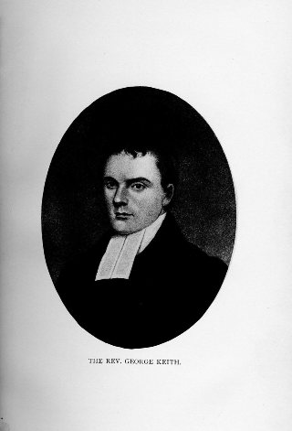

In 1905, Elizabeth Mary Sinnott, wrote the annals of the Sinnott and allied families. Within the section pertaining to the Jess Family, she provided the following reference to Archibald Silver. This reference is as follows (Sinnott,1905):

“Archibald Silver, the elder, was an early settler in Burlington County, New Jersey, where, also, his brothers James and John settled. By deed of 10 October 1686, Archibald Silver purchased from Governor Byllinge one hundred acres of land, located on the south side of the north branch of Rancocas Creek, adjoining land of Dr. Robert Dimsdale, and on 10 May 1695, he sold the same to James Smith. In the deed to Smith, Silver is styled “of Northampton Township, Burlington County, Planter.” About the time he made this conveyance, he removed to Mannneton Creek, Salem County, and died there in 1703, leaving personal estate valued at over one hundred and ninety pounds. His estate was administered by Joseph Burgen, doubtless a brother-in-law, and the same who married Jane Silver, 23 March, 1691-92. Archibald Silver married Christian Cheene, a young woman who had resided in the family of the Reverend George Keith, and by this marriage he acquired a tract of thirty acres of land in Monmouth County.

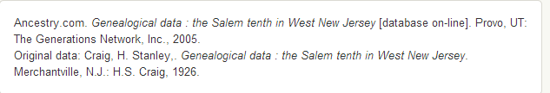

From page 67, below.



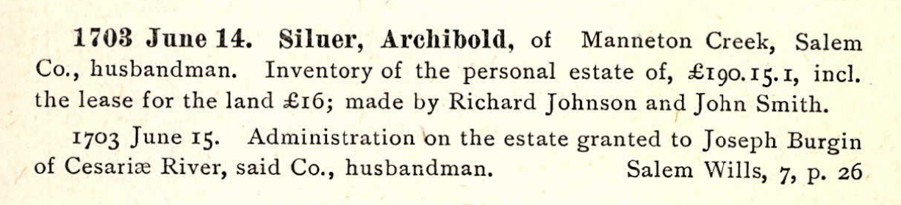



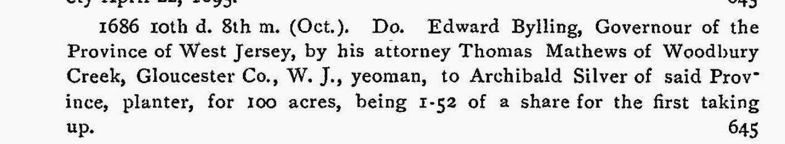

Source for above:





Source for above:



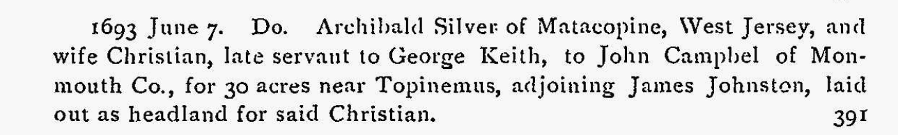

Source for above:



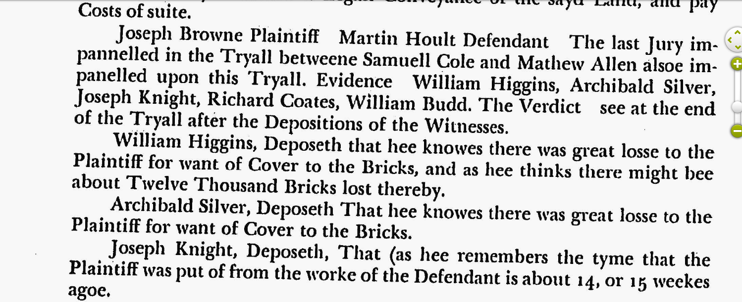

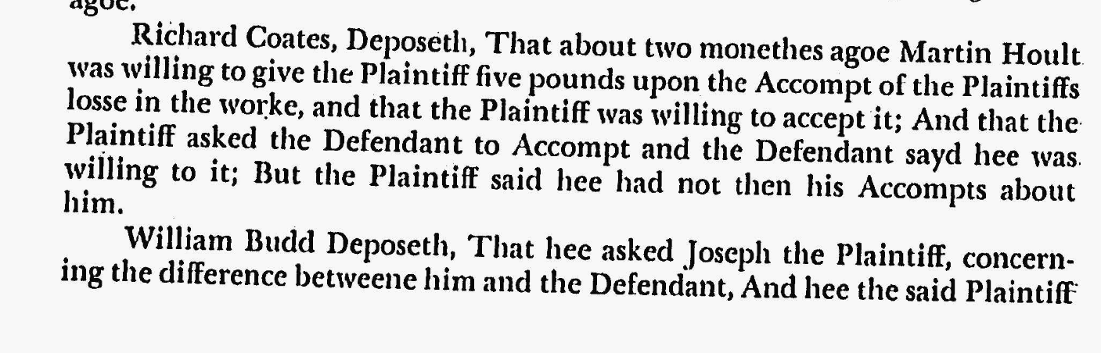

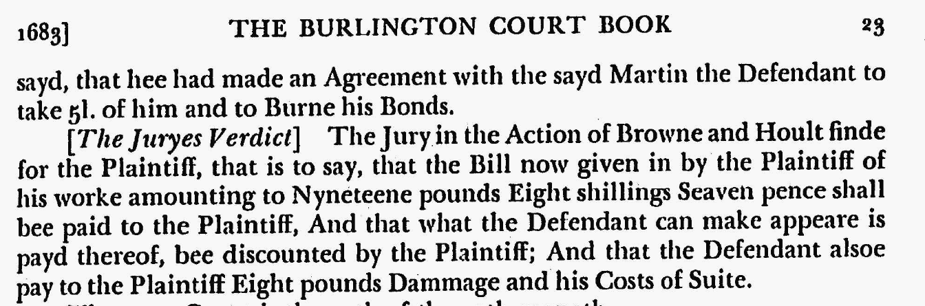

Source for above:

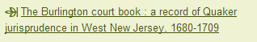







Archibald Silver married Christian Cheyne. Christian Cheyne was also identified in David Dobson's book, *The Original Scots Colonist of Early America, Supplement 1607-1707,* page 28, as an earlier settler. Dobson's entry for Christian Cheyne, is as follows:

"CHEYNE, CHRISTIAN, an indentured servant imported into East New Jersey by George Keith 2.1685, married Archibald Silver in Matacopine, West New Jersey. [EJ Deeds, Liber A, fo. 226; Liber D]"

He had one sibling, namely John, who was also from Scotland.

Archibald Silver lived in USA. He lived in Salem, New Jersey, USA. He arrived in West New Jersey between 1635–1699. He arrived in West New Jersey between 1680–1689. Lease assigned to him from his brother, John Silver: 21 Dec 1695 in Salem County, New Jersey, United States (Proof that John and Archibald Silver are brothers)

Archibald Silver and Christian Cheyne had the following children:

1. Archibald Silver was born in 1696 in NJ, USA. He died on 23 Oct 1769 in Salem County, New Jersey, United States (Married at Salem Monthly Meeting). He married Mary Cowgill on 14 Feb 1720 in Chesterfield, Burlington, New Jersey, USA (Chesterfield Monthly Meeting).

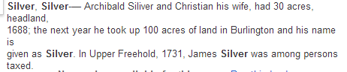

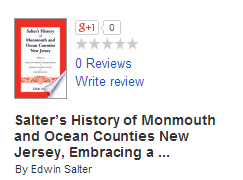Source for above

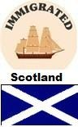

**James Silver, brother of Archibald**

**pages 419 and 420**

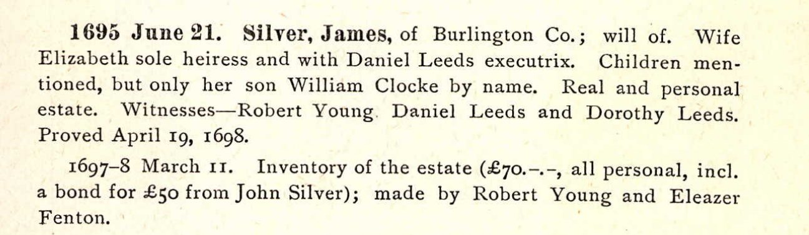

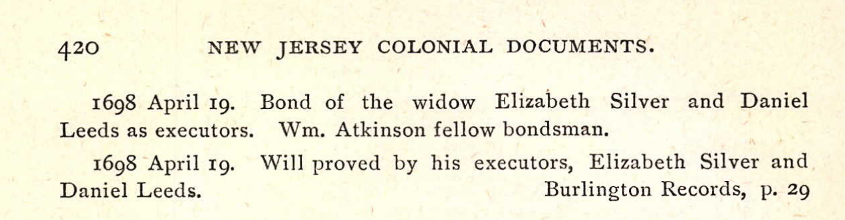

Above source: 

**John Silver, brother of Archibald and James Silver**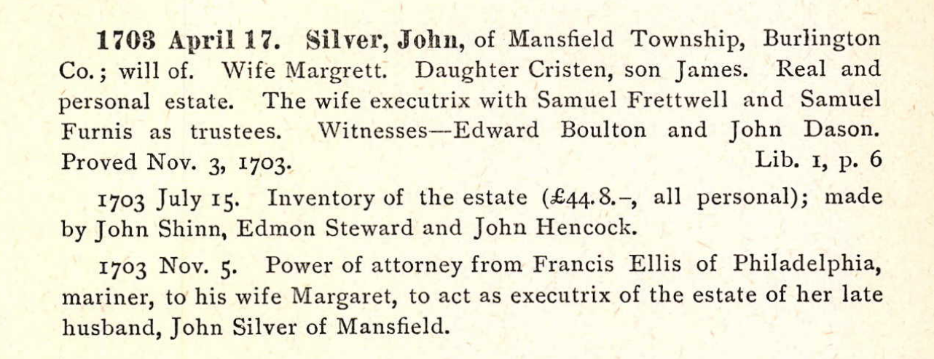

**Page 420**